Heuristic Analysis:

The three heuristic functions I choose are as below.

1. The first heuristic function I tried is that in the beginning of the game (when # of blanks are more than half of total cells), use #my_move – 2 * #oppo_move, after that I use #my_move - #oppo_move.

I was thinking that when the game just started, we could use a more aggressive method. As game went on, the number of available moves decreased, so it’s possible that the #my_move – 2 * #oppo_move became negative while #my_move - #oppo_move was still positive so that agent would make a better choice using #my_move - #oppo_move.

Below is one of the test results. Seems this function did not work well as I expected.

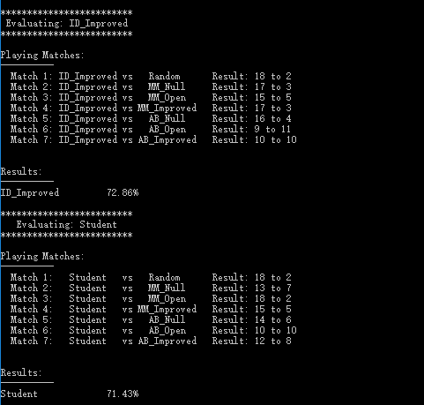

1. The second heuristic function I tried is #my_moves / #oppo_moves. I replace the subtraction in the function “#my_moves - #oppo_moves” with division. Assume we have below two choices for the next move,

Move choice 1: #my_moves = 4, #oppos_moves = 2 and

Move choice 2: #my_moves = 3, #oppos_moves = 1

The function #my_move - #oppo_move gives a tie between the two choices, so computer might pick choice 1, however, the best move should be choice 2 as there will be only 1 move left for opponent if choosing this move. Using #my_moves/#oppo_moves yields this result.

I think the idea behind this is that #my_moves / #oppo_moves is that due the characteristic of the the y=1/x curve, when maximizing the value of this division, the #oppo_moves will be greatly reduced, much faster than the linear function of #my_moves - #oppo_moves.

Below is one of the test results with NUM_MATCHES = 25

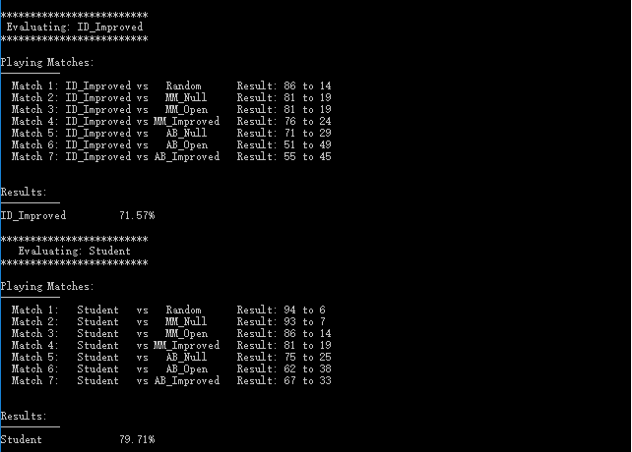

This function seems to be better function as expected.

1. The third function I use exp() to both of the two variables because I think the exp curves are steeper thus should more greatly restrict the opponent’s moves. However, I think exp() function is a time-consuming function, so I do not expect this function to be better than last function. Below is one of the results with NUM_MATCHES = 25

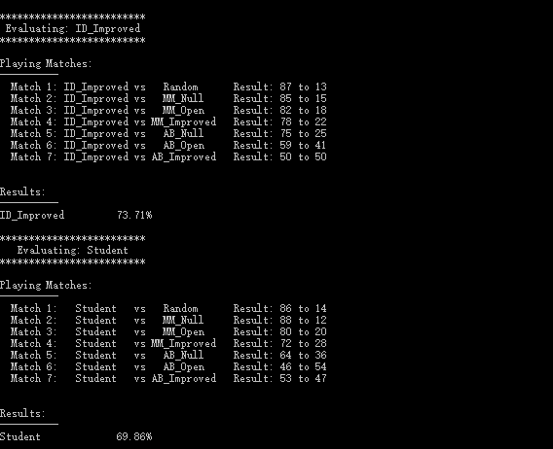

As above result shows, this function did not perform well, but this is not a surprise. The time consumed on heuristic function calculation is too much.

So finally I choose function 2 #my_move / #oppo_move as my heuristic function. Because (1) it performs better than the other two. (2) the calculation is easy and straightforward and easy to implement. (3) the steep curve of #my_move / #oppo_move will reduce the number of opponent’s move faster than the linear curve of #my_move - #oppo_move, but less overhead than the exponential functions. So I recommend using #my_move / #oppo_move as heuristic function.

***Revised on 4/4/2017 as per suggestion from the reviewer:***

Table 1 shows a summary of the comparison of the three heuristic functions. For each heuristic function, the tournament was executed five times (five rounds). We can see from the table that heuristic function (2) consistently performed better than ID_Imroved, and it’s the best heuristic function among the three.

Table 1. Heuristic functions comparison result

|  |  |  |  |
| --- | --- | --- | --- |
|  | Round | ID_Improved | Student |
| Heuristic Function (1) | 1 | 71.43% | 69.29% |
| 2 | 76.43% | 72.14% |
| 3 | 70.71% | 77.86% |
| 4 | 71.43% | 68.57% |
| 5 | 74.29% | 73.57% |
| **Average** | **72.86%** | **72.29%** |
| Heuristic Function (2) | 1 | 71.43% | 80.00% |
| 2 | 72.86% | 78.57% |
| 3 | 76.43% | 78.57% |
| 4 | 68.57% | 86.43% |
| 5 | 67.86% | 81.43% |
| **Average** | **71.43%** | **81.00%** |
| Heuristic Function (3) | 1 | 74.29% | 71.43% |
| 2 | 73.57% | 67.14% |
| 3 | 72.14% | 69.29% |
| 4 | 69.29% | 72.14% |
| 5 | 75.71% | 65.00% |
| **Average** | **73.00%** | **69.00%** |